**Geographical Information Systems**

**Assignment 2**

Student Name: Nour Muhammed

Student ID: 20200605

Group No.: S1

**Steps:**

**Preparing data**

1. From the map we created last assignment we have Dokki Layer 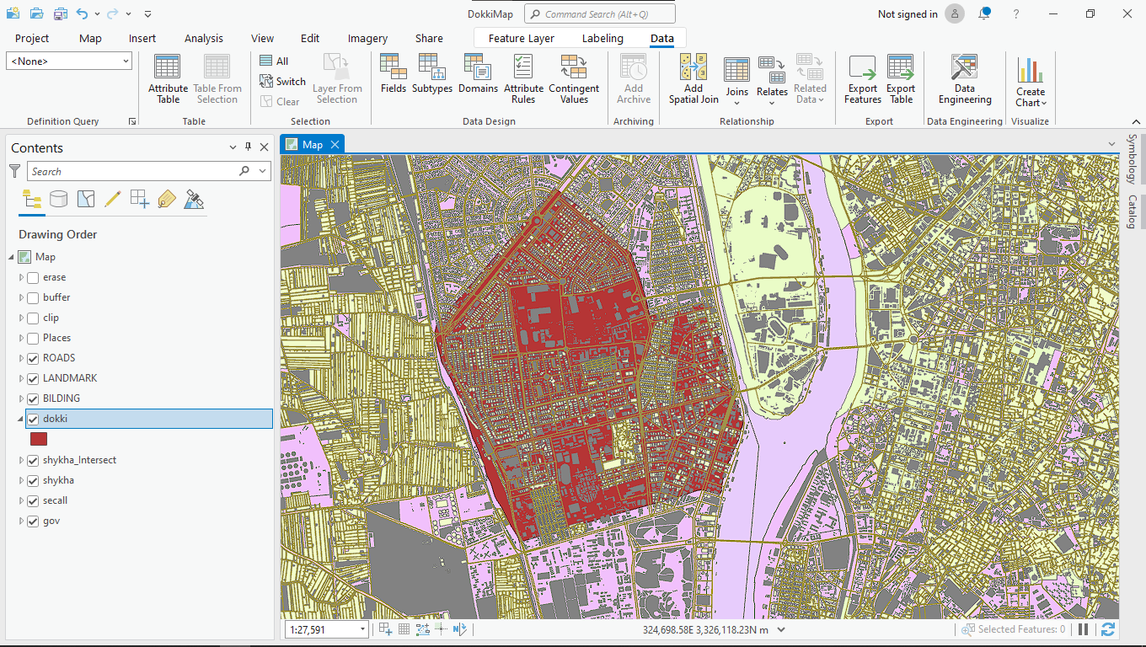
2. We will extract (schools – Hospitals – clubs ) using select feature tool using the queries :
3. From Landmarks select * where A_Name1 contains text ‘مستشفى’ A screenshot of a computer

   Description automatically generated

Right click on landmarks layer -> selection -> Make Layer from Selected Feature

1. From Landmarks select * where A_Name1 contains text ‘نادى ‘

Right click on landmarks layer -> selection -> Make Layer from Selected Feature

5. From Landmarks select * where A_Name1 contains text ‘مدرسة ‘  
  
Right click on landmarks layer -> selection -> Make Layer from Selected Feature

**Clipping Data on Dokki Layer**

1. From analysis tab we will use pairwise clip to clip Roads on Dokki Layer A screenshot of a computer

   Description automatically generated
2. Also, we will clip schools on Dokki Layer

1. And we will clip Hospitals on Dokki Layer A screenshot of a computer

   Description automatically generated
2. And we will clip clubs on Dokki Layer A screenshot of a computer

   Description automatically generated

Now we have All layers we will use for our condition Clipped.

**Buffering Layers**

1. For each layer we will make a buffer with the space in the assignment description

Roads will be buffered 50.

Hospitals and clubs will be buffered 500.

And Schools will be buffered with 1000.

**Erasing redundant parts from the layer**

1. Using an erase tool, we will start erasing roads with club’s layer. A screenshot of a computer

   Description automatically generated
2. Also, we will erase the result from the previous step with hospitals.

1. After that we will use the result and erase the result with schools

1. With the final layer we will use the query to find shape area >= 500

